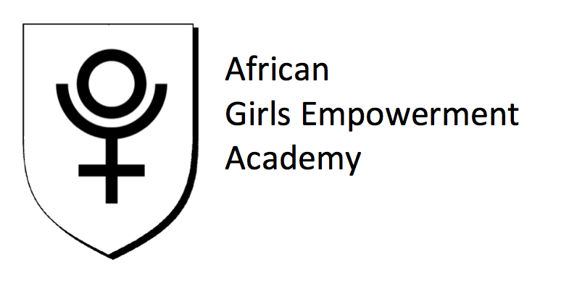

The mission of the African Girls Empowerment Academy **(AGEA)** is to empower African girls with entrepreneurial and health care skills within their communities and inspire them to seek better life styles for themselves and their families.

Through free tutorials, discussions, exercises, guest speakers and a variety of other dynamic educational activities we will deliver unique and innovative programs dedicated to inspiring and guiding African girls from 15 to 23 years of age to create and manage their own business, connect with their selves, rebuild self-esteem and empower others.